June 25th, 2019

SHAPE Push-Button Technology Recognized

at Cine Gear Expo Awards 2019
Montreal, Canada - SHAPE is honored to learn that its patented push-button technology stood out in the support technology category at Cine Gear Expo 2019.

BALANCE AND CONTROL

The SHAPE red push-button is unmistakable; it’s used and trusted by countless professionals in the industry. Having worked in the industry as a 1st camera assistant and director of photography, president Mylene Girard understood that, when on a set, time is an expensive commodity.
“The biggest challenge from a camera operator’s perspective is efficacy. When designing the push-button technology, we wanted the simplest solution that would give the camera assistant complete control of his set up, with one push of a button. Operating a camera is like dancing; it’s all about organization, timing, and how you stand out.”
Push, unlock, set, lock – voilà.
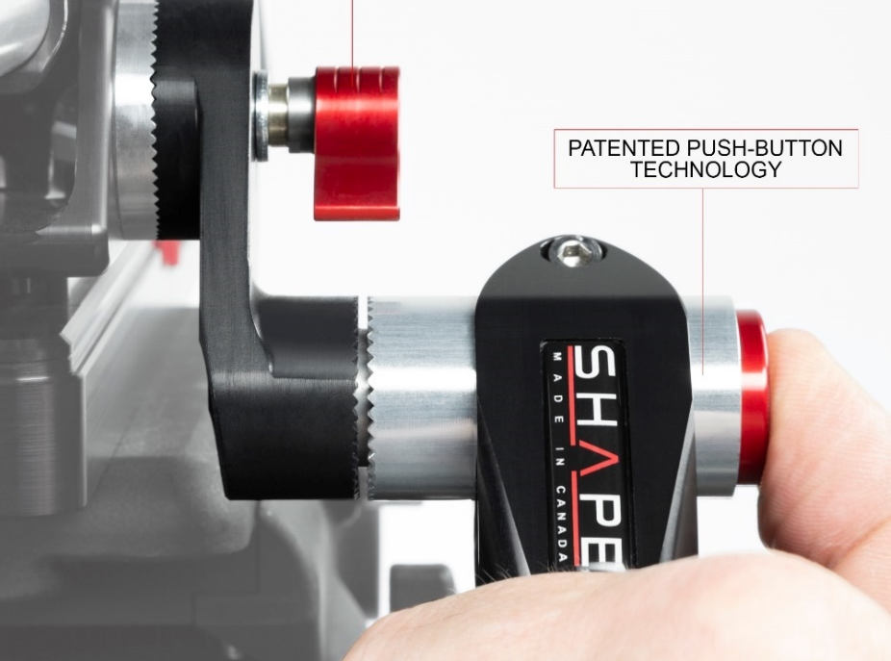
ONE PUSH OF A BUTTON
SHAPE was granted a global patent on the push-button technology in 2009. Its unique concept has been widely acclaimed since then. At Cine Gear in 2019, SHAPE launched two new sizes for the push-button, originally 25 mm wide.
According to Charles Vallieres, co-founder of SHAPE, the button sizes will vary based on their placement on the rig. The handgrip buttons will remain the original size, while the arm and LCD brackets will offer a smaller version; 19 mm or 15 mm.

CONTINUED INNOVATION

While keeping an eye on support solutions for new and upcoming products, SHAPE is planning to expand its innovative approach to new markets in the coming year. New products in development will be launched soon.

